|  |
| --- |
| User manual |
| User manual for Barroc-it app |
|  |
| Groep 2: Jean-Pierre / Lukasz / Youssef |
|  |

# Content

There are the following subjects we’re going to talk about in this manual:

### 1. opening the application

### 2. *login into your department*

### 3. Sales

### 1. Home screen:

### 2. View customer info:

### 3. Edit customer:

### 4. Making customer:

### 5. Deleting customer:

### 6. Print info:

### 4. Development

### 1. Home screen:

### 2. View customer info

### 3. View project info:

### 4. Edit customer

### 5. Edit project::

### 6. Add appointment:

### 7. Print info:

### 5. Finance

### 1. Home screen:

### 2. View customer info:

### 3. View project info:

### 4. View invoice’s :

### 5. Edit customer info:

### 6. Add invoice:

### 7. Change invoice status:

### 6. Admin:

### 1. home page

### 2. Add user:

### 3. Edit user:

### 4. Delete user:

### 5. Trash bin:

### Opening the application

Once you have the application up and running and everything is setup correctly you should be able to go on your web application by typing in the link in your address bar:

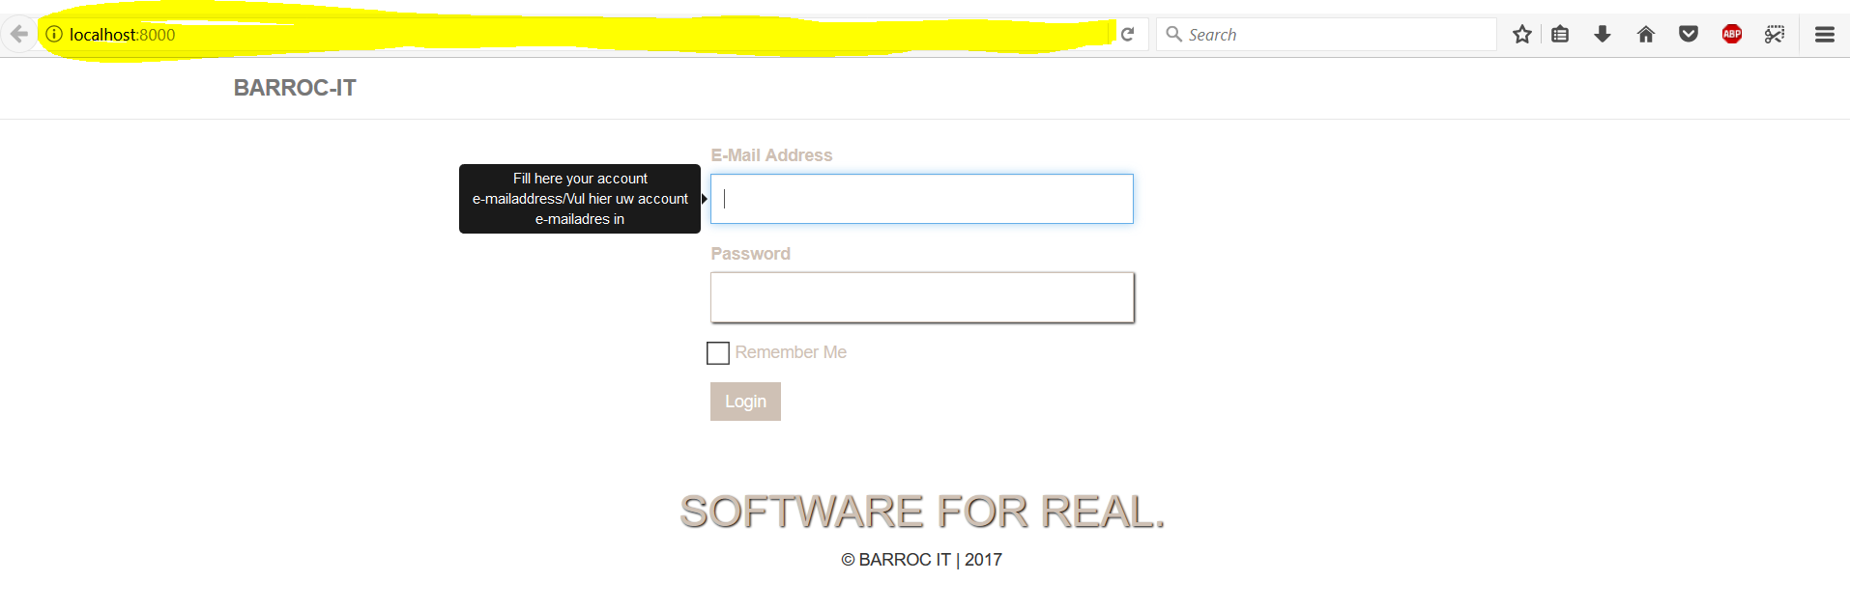

You should be ending up at the login page of our application.

*login into your department*

so once we are on the login page we can login with our credentials of our application:

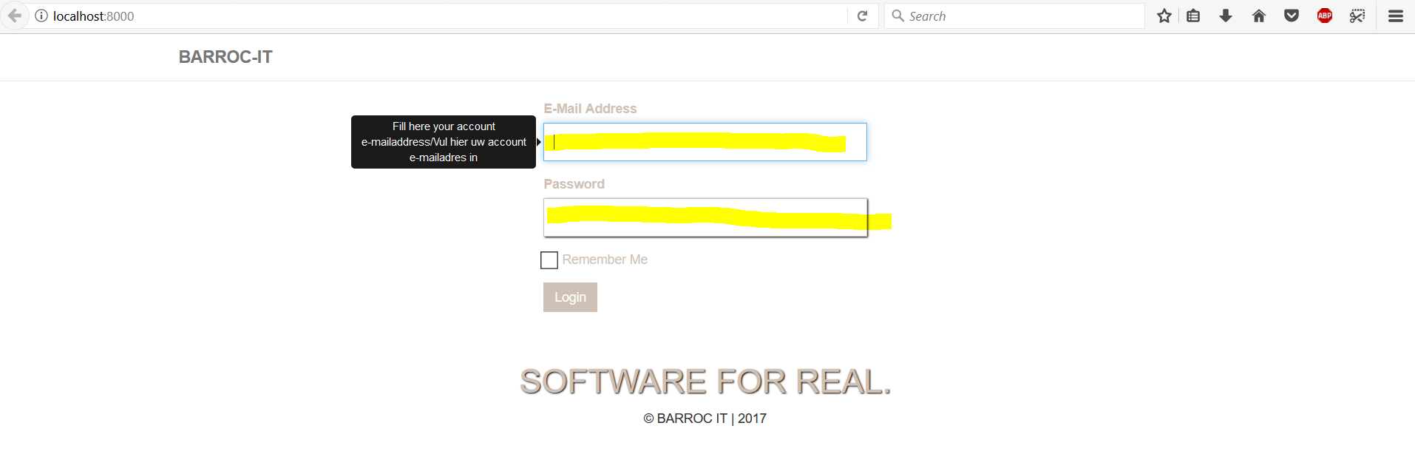

Please fill in the email of your department and click on “login”:

**Email sales:** [sales@barroc-it.nl](mailto:sales@barroc-it.nl)

**Password sales:** sales

**Email development:** [development@barroc-it.nl](mailto:development@barroc-it.nl)

**Password development:** development

**Email finance:** [finance@barroc-it.nl](mailto:finance@barroc-it.nl)

**Password finance:** finance

**Email admin:** [admin@barroc-it.nl](mailto:admin@barroc-it.nl)

**Password admin:** admin

That’s al that have to be done.

## sales

to be able to login into sales please see the instructions above

### home screen

once we’re have logged in we will end up at the home page with the info the department sales has to be able to view:

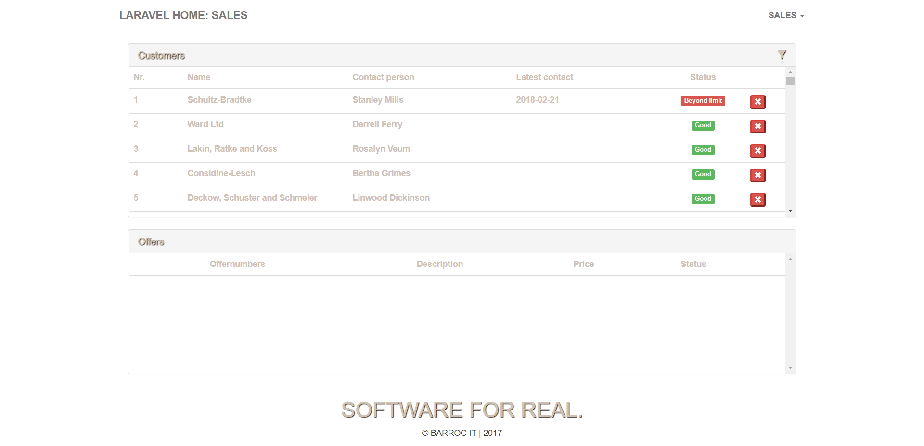

### view customer info

in order to view the customer info we have to click on the name of the customer:

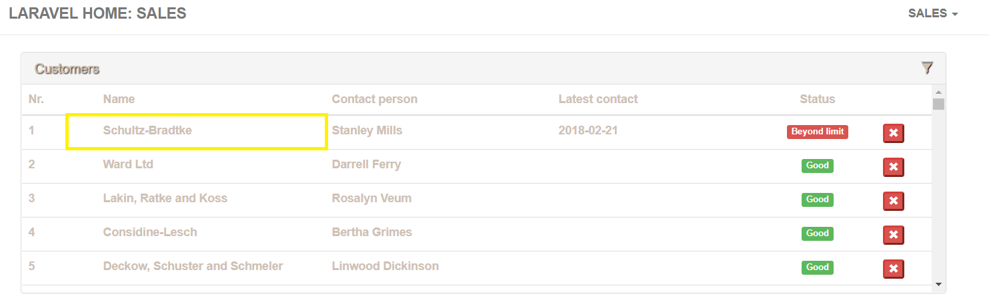

And u will end up on the customer view page:

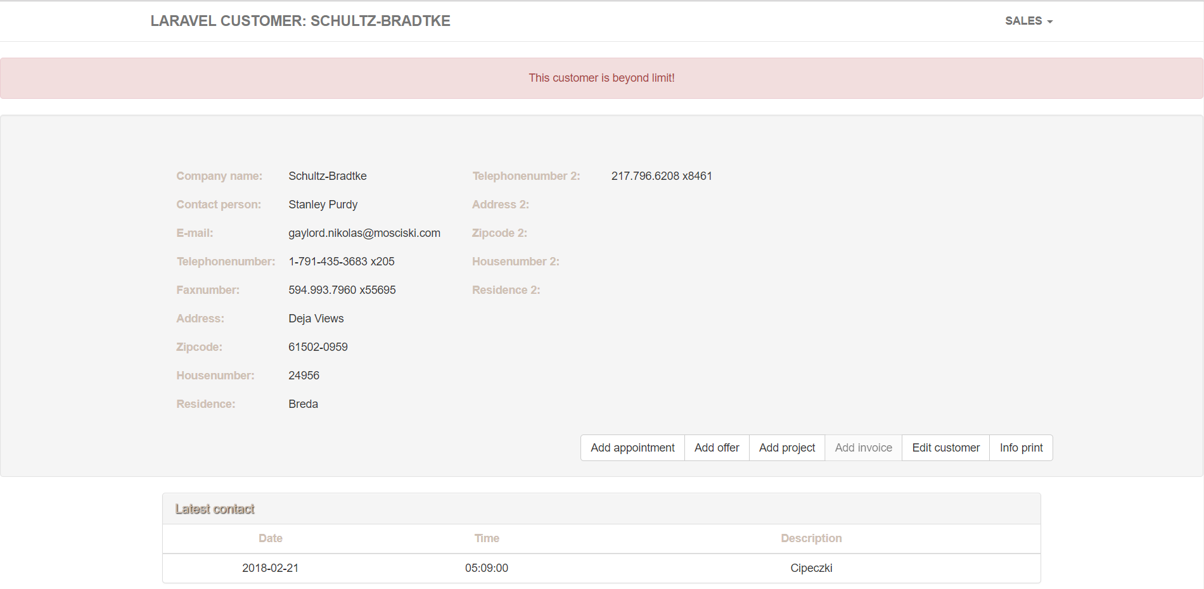

On this page you will be able to see all the info of that customer

### edit customer

if you want to edit the customer we need to click on “Edit customer”

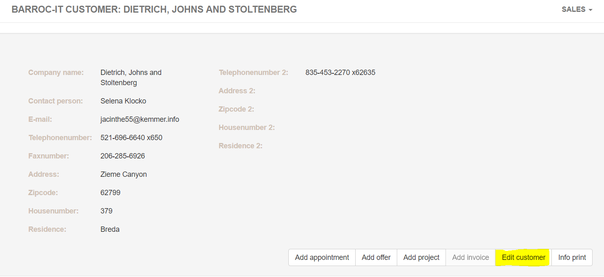

and we will end up on this page where you have to fill in all the info of the customer/ the info what you want to change:

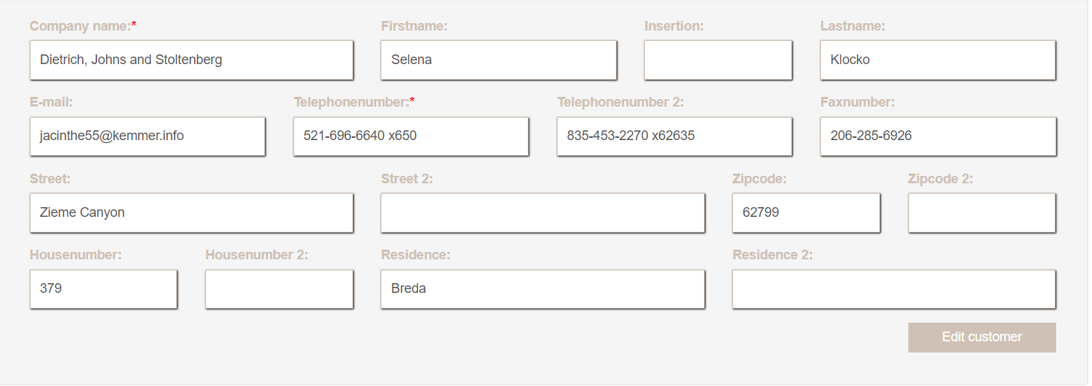

Once done click on “Edit customer ” on the bottom right of the dialog

### making customer

for making a customer we go to the top of the screen where our navigation bar is located. Once you found the navigation bar click on “sales” and a hamburger menu will pop-up, from there of we click on “add Customer”

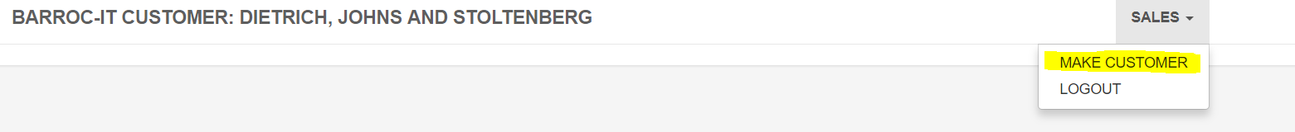

Once u clicked on the “make customer ” we should end up at the add customer page:

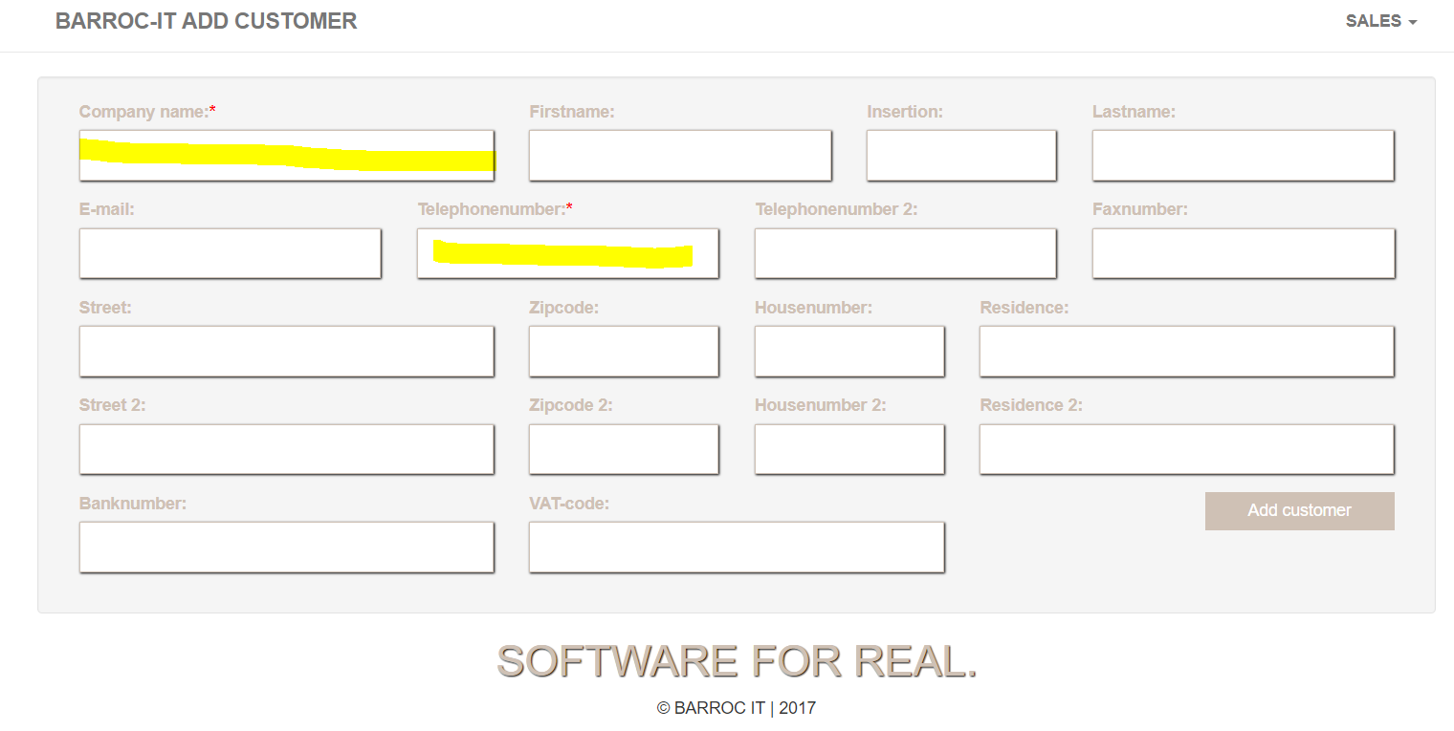

On order to add a customer we have to fill in at least 2 field: “company name” and “telephone number” once all the info has been filled in click on “Add customer” and a new customer has added to your database.

### deleting customer

if we want to delete a customer we should be at the home page of our department (if not click on the barroc-it text on the top left corner of our screen).

Once we are at the home page we have a dialog of all customer with a red cross behind it.

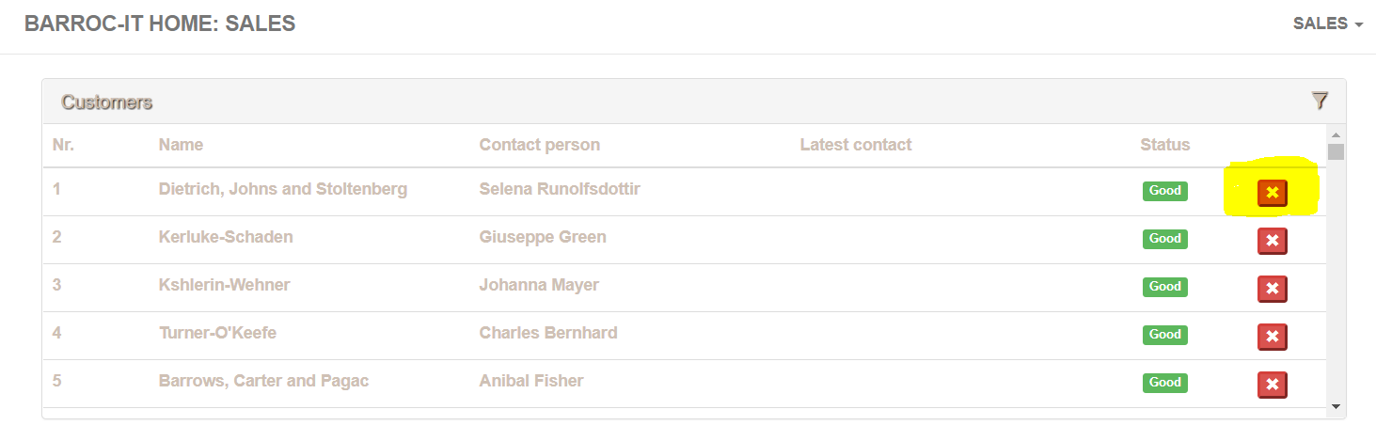

If we want to delete that customer we simply click on the “red cross” and the customer will be deleted

### print info

if we want to print the customer info we have to click on a customer like we did earlier to be able to view the customer details we want to print:

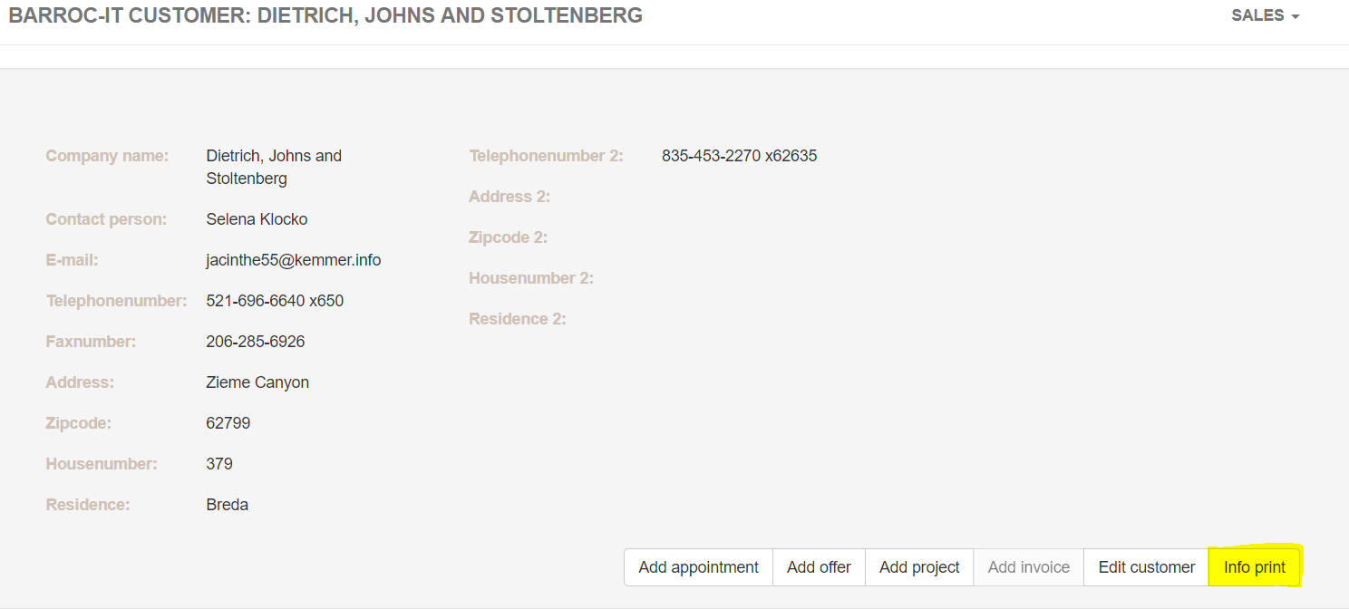

If we want to print the info we only have to click on “info print”

## Development

To be able to view the development page we must be logged in as a developer (see login instruction above).

### Home screen

Once we’re logged in as developer we will end up at the home page of developer where the appropriate info will be displayed:

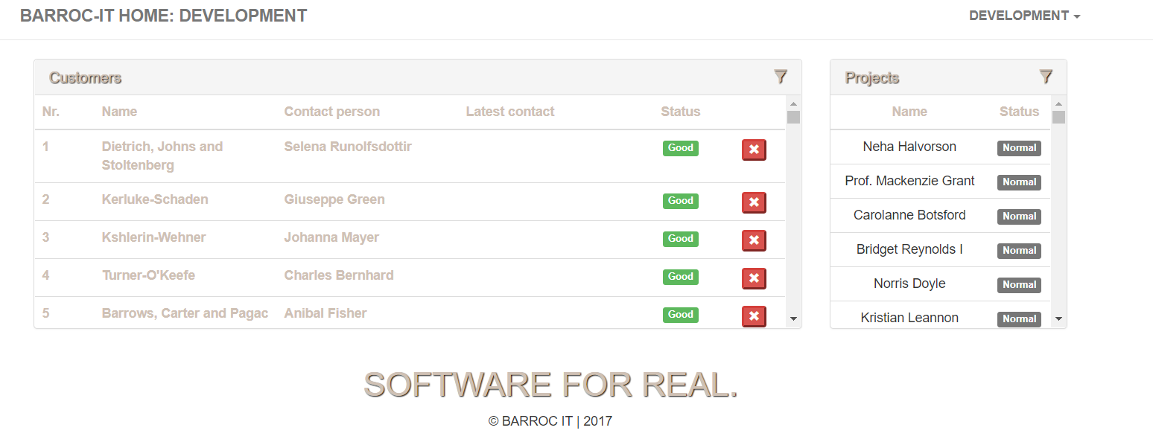

### View customer info

If we want to view the customer info we have to click on ”the customer name”

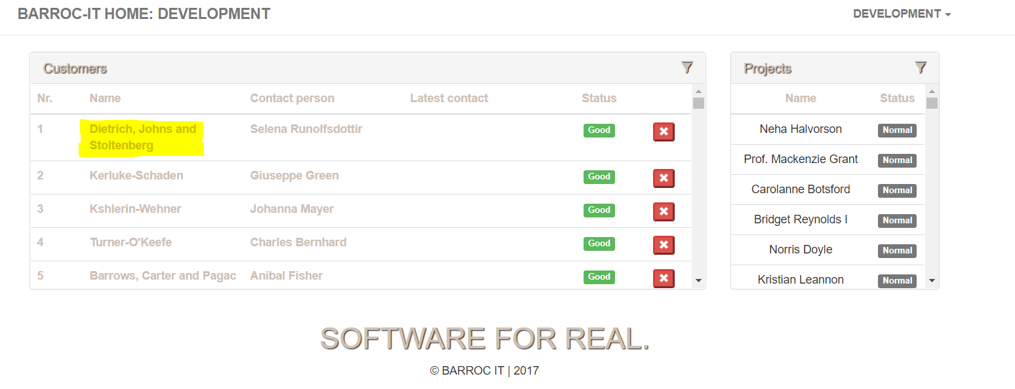

Once we clicked on that we will be directed to the customer info page of that customer:

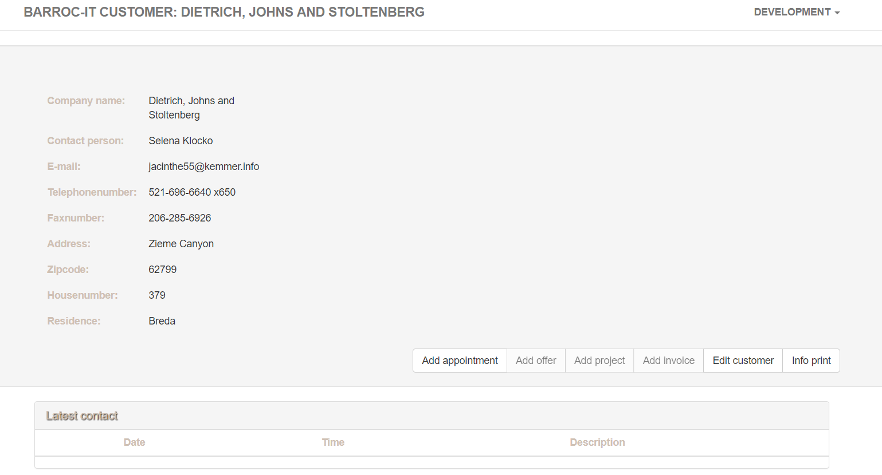

Here we can see all the info where development can do something with.

### View project info

If we want to view the project info we have to click on the project dialog and the name of the project:

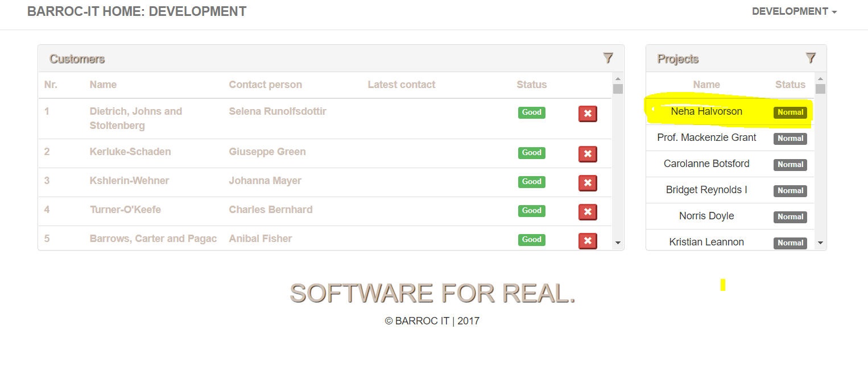

Once we clicked on the project we will be directed to a page with all the project info:

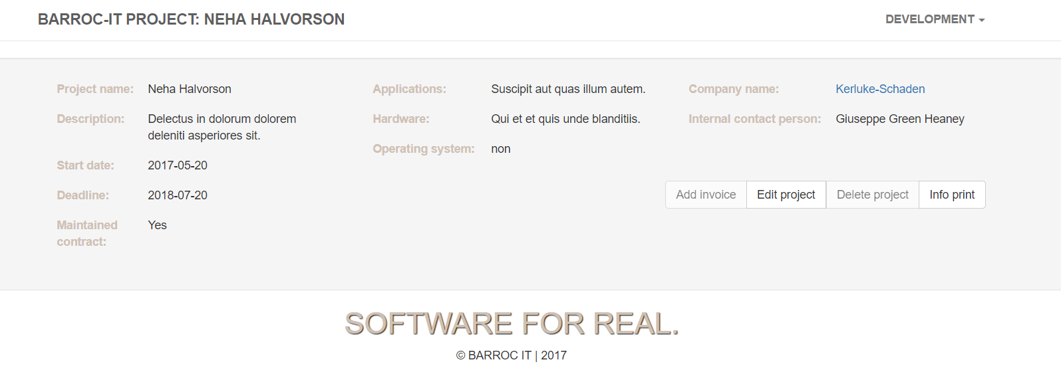

### Edit customer

If we want to edit the customer we have to click on the customer first to view the customer info it-self like we did above.

Once we clicked on that we click on edit customer:

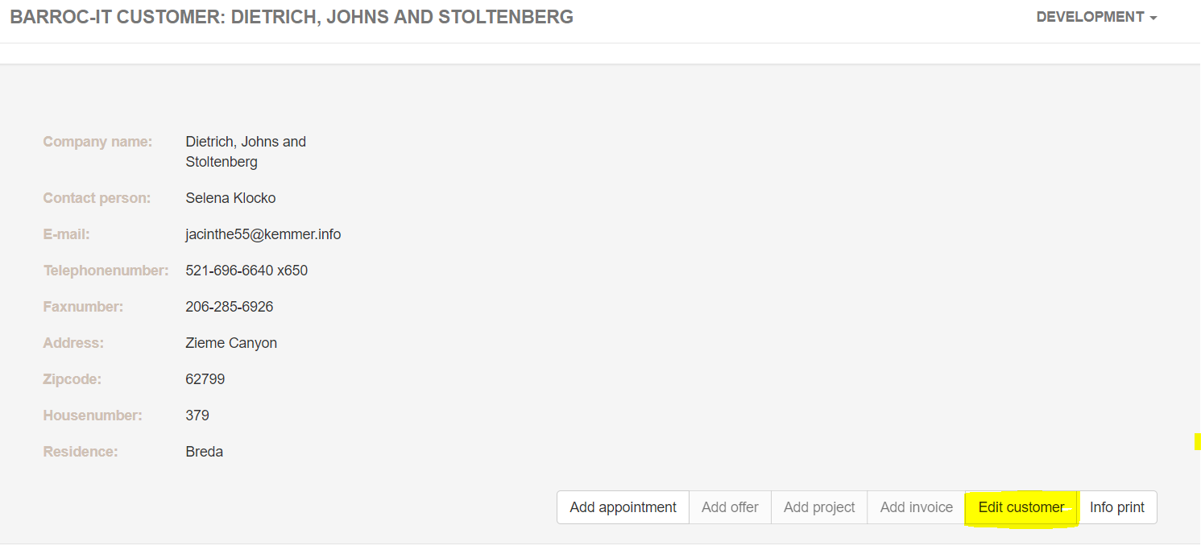

Once we clicked on ”edit customer” we will be directed to a edit customer page:

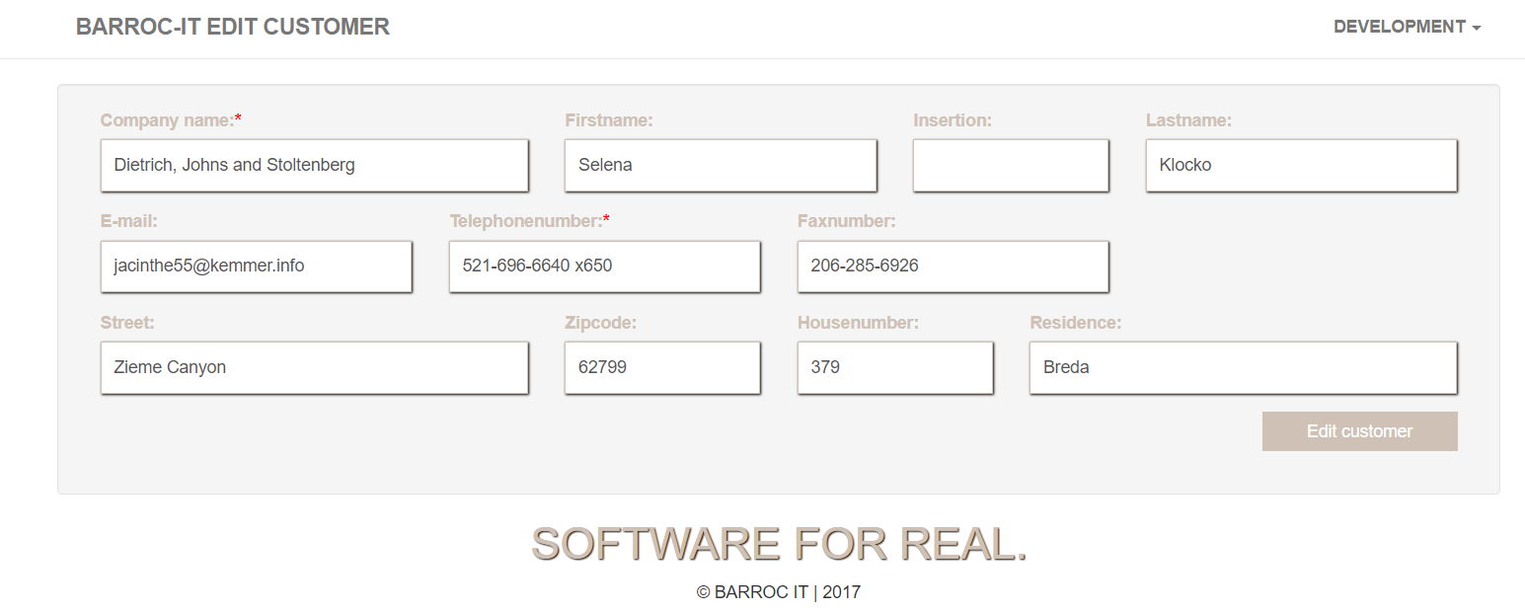

Here we can edit all the customer info we need to edit as developer being. When we are done editing click on “Edit customer” :

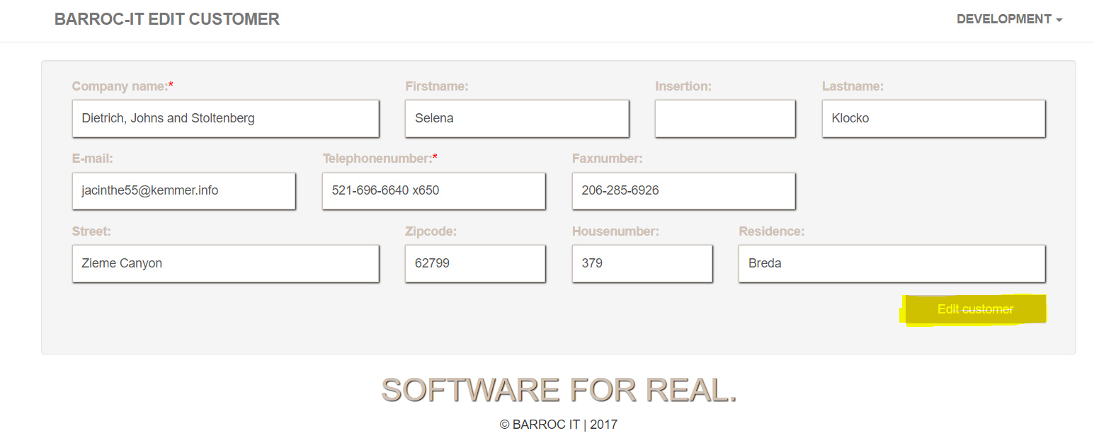

### Edit project

If we want to edit a project we need to go to the project info, like we explained earlier.

Once we’re on the info page we need to click on “Edit Project”:

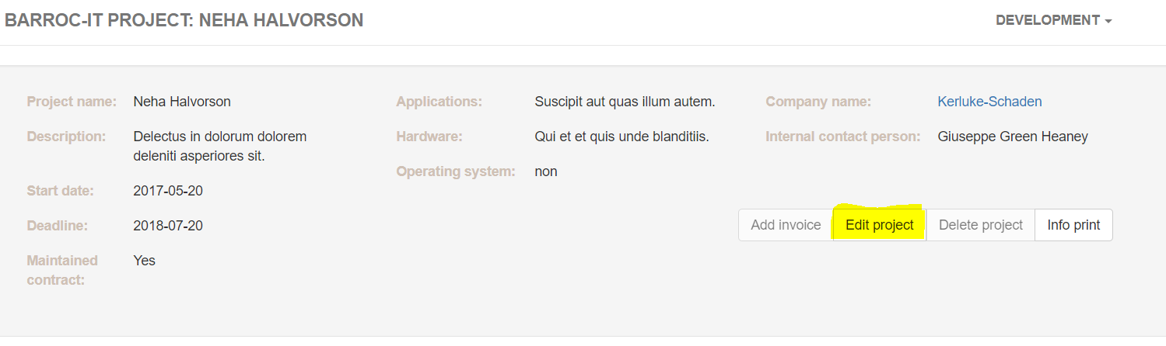

Once we clicked on the “edit project” we will be directed to the editing page of that project:

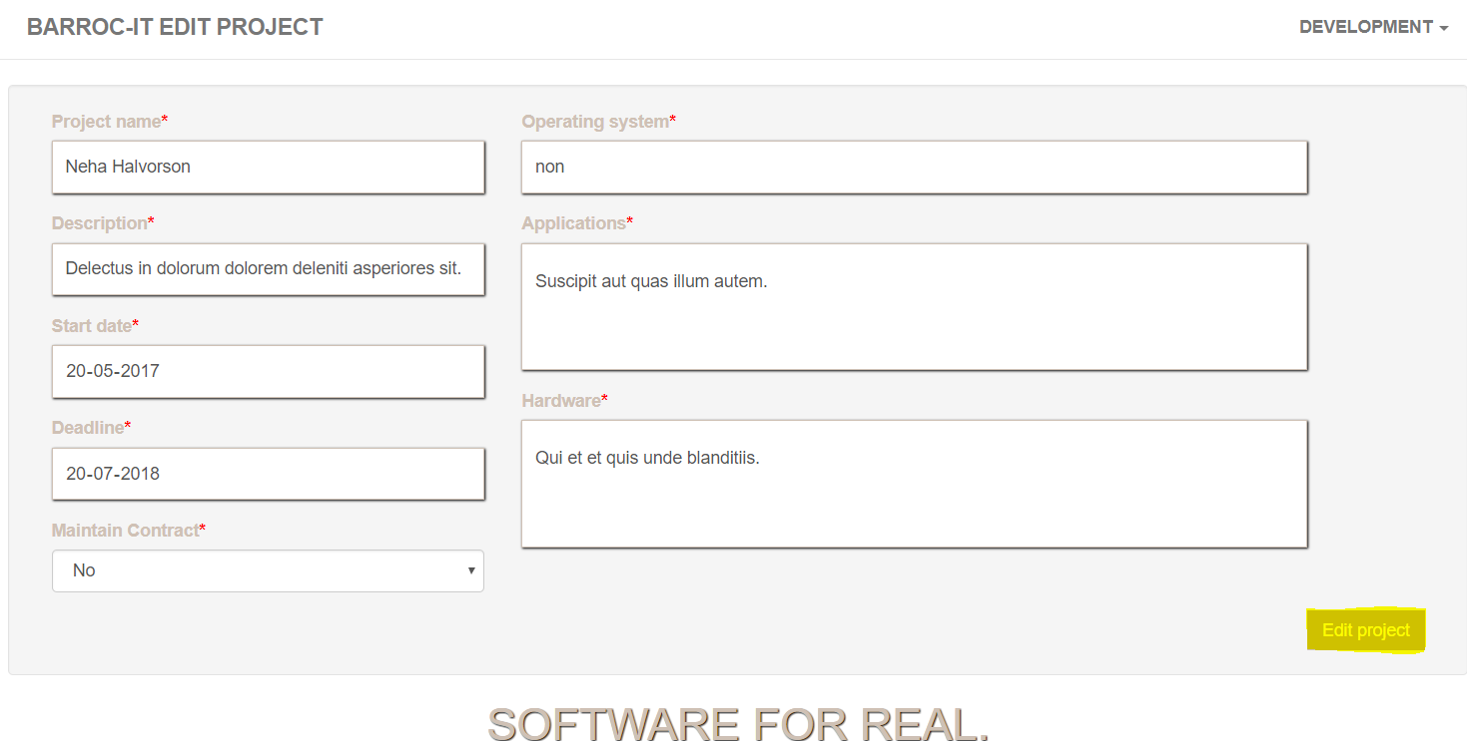

Afterwards we can fill in the changes we made to the project. Once were done we can click on “edit project” and the project will be edited.

### Add appointment

If we want to add an appointment we need to be at the info page of the customer where we want to add an appointment.

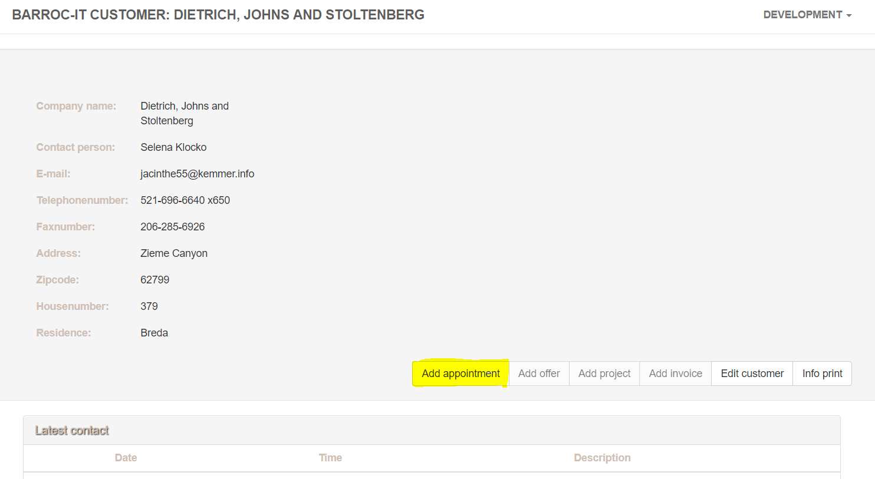

Once we are on that page we want to click on “add appointment”, once we clicked on it there will appear a dialog box where we can put our appointment details in:

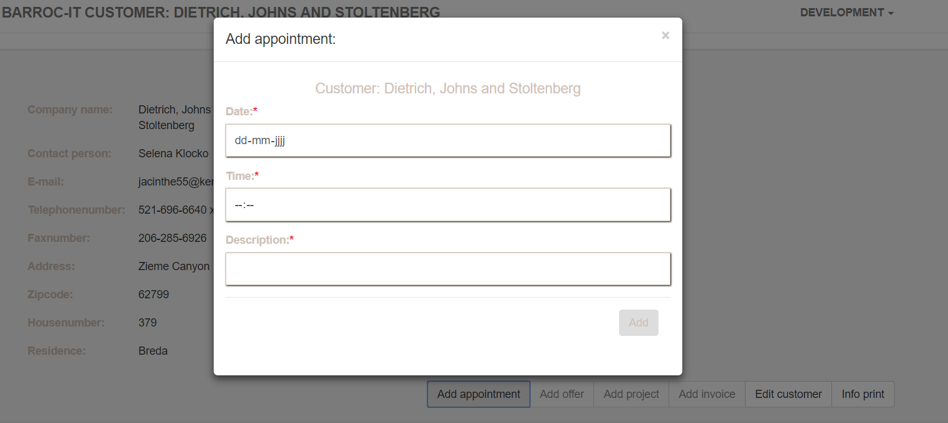

Once we have filled in the field (make sure to fill in all fields!) we can click on add and our appointment will be added.

### Print info

If we want to print the project info we need to be at the project info page, once we’re there we can click on “print info” :

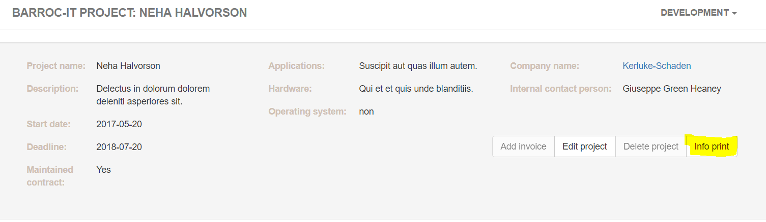

And from there off we can print the project info.

## Finance

We need to be logged in as finance in order to continue with the manual (look at login instruction above)

### Home page

Once we’re logged in as finance we will be directed to the home page of finance:

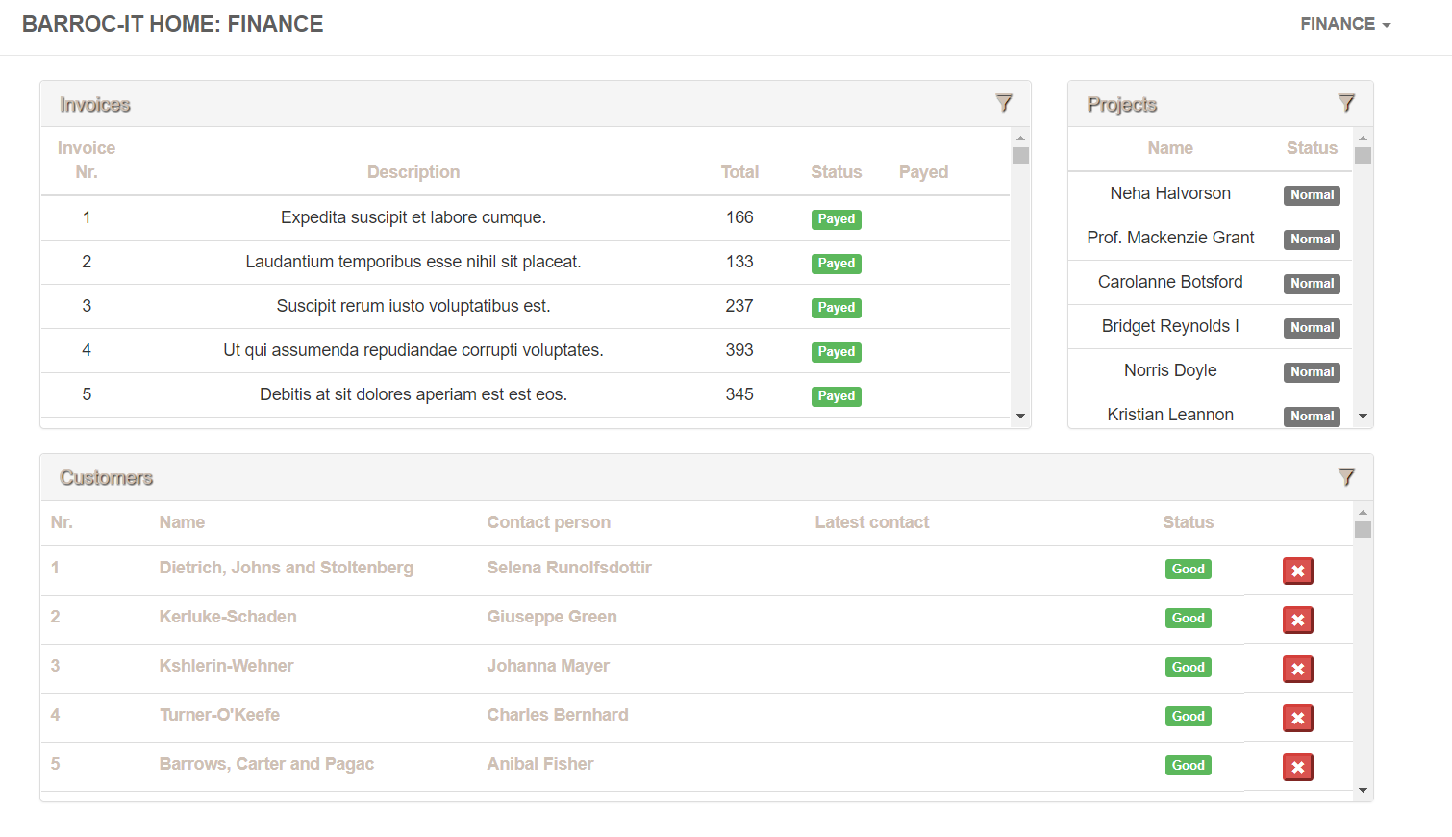

### View customer info

If we want to view a customer as finance all we need to do is click on the customer we want to view:

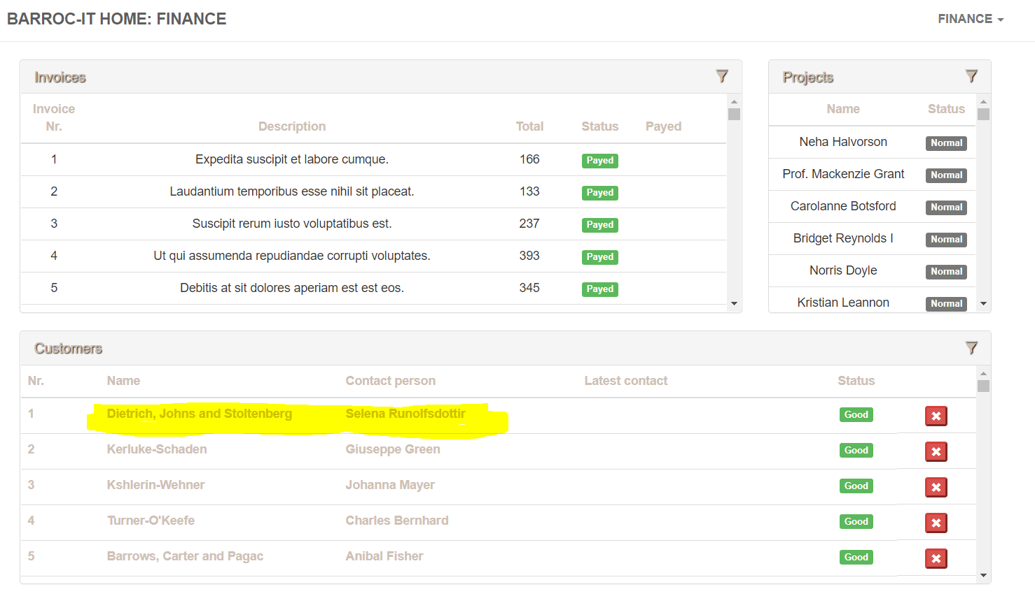

Once we clicked on the customer a customer info page will be shown:

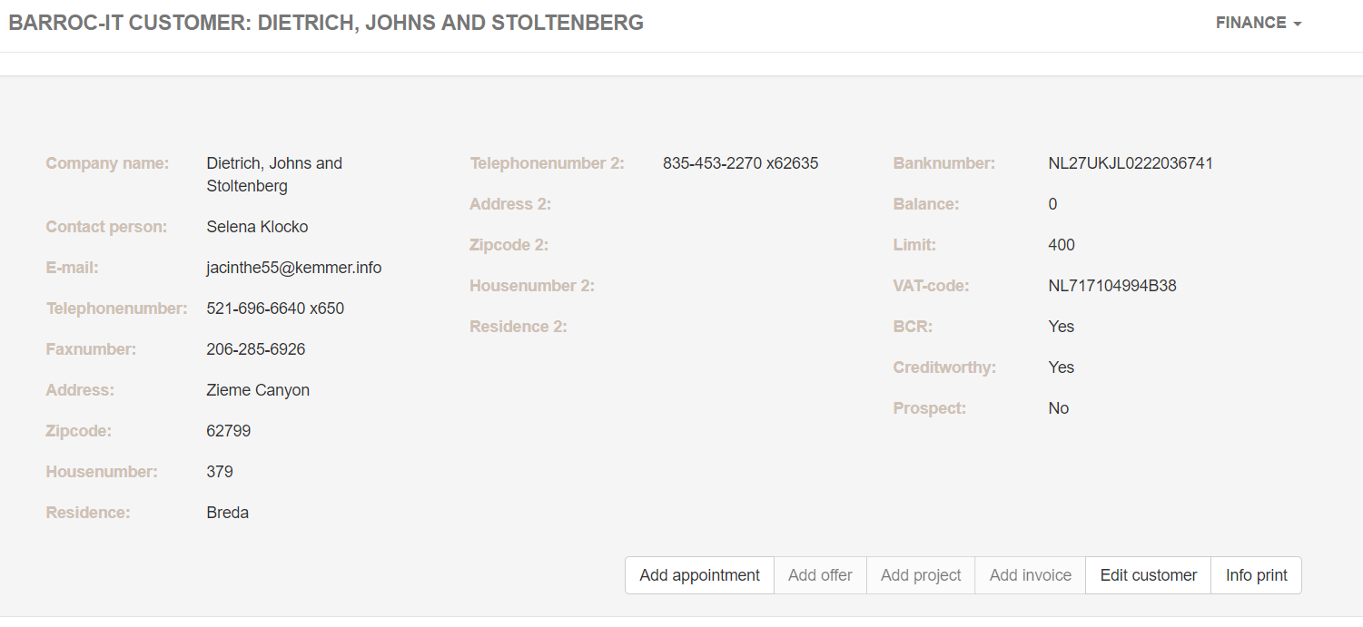

### View project info

If we want to view an project we have to click on a project in at the home screen:

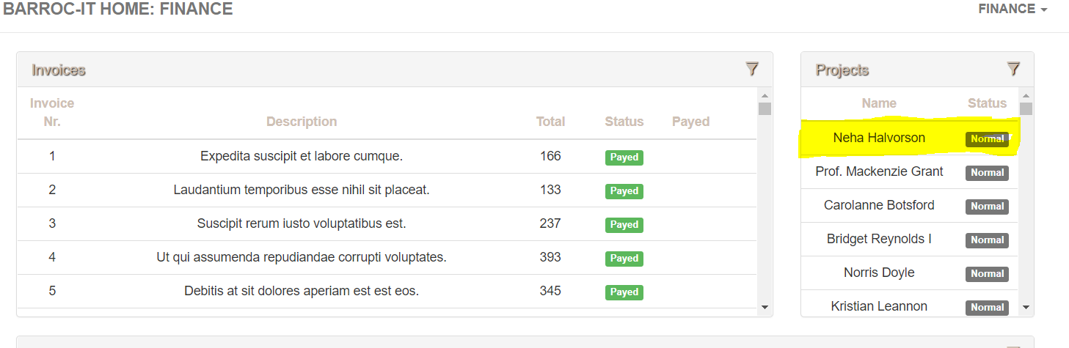

Once we clicked on it we will get all the info of that project on the project info page:

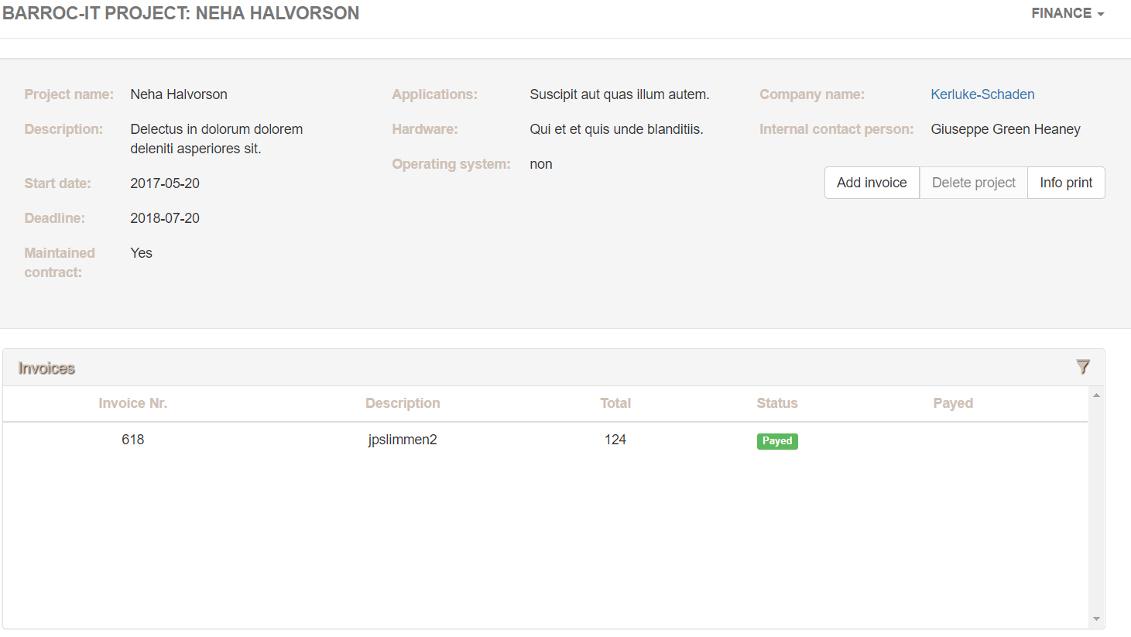

### View invoice

If we want to see all invoices we can go to the homepage by clicking on the Barroc-it logo on the top left corner of the page.

Once we’re on the home page we will be able to view all the invoices the company.

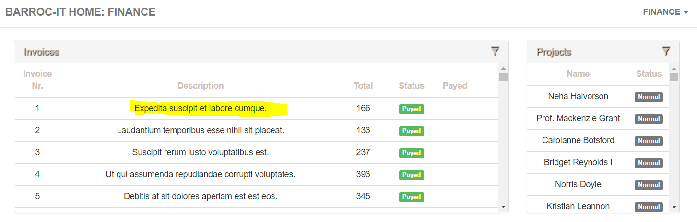

### Edit customer info

If we want to edit the customer info we need to go to the customer info page like described before.

Once we’re there we can click on “edit customer”

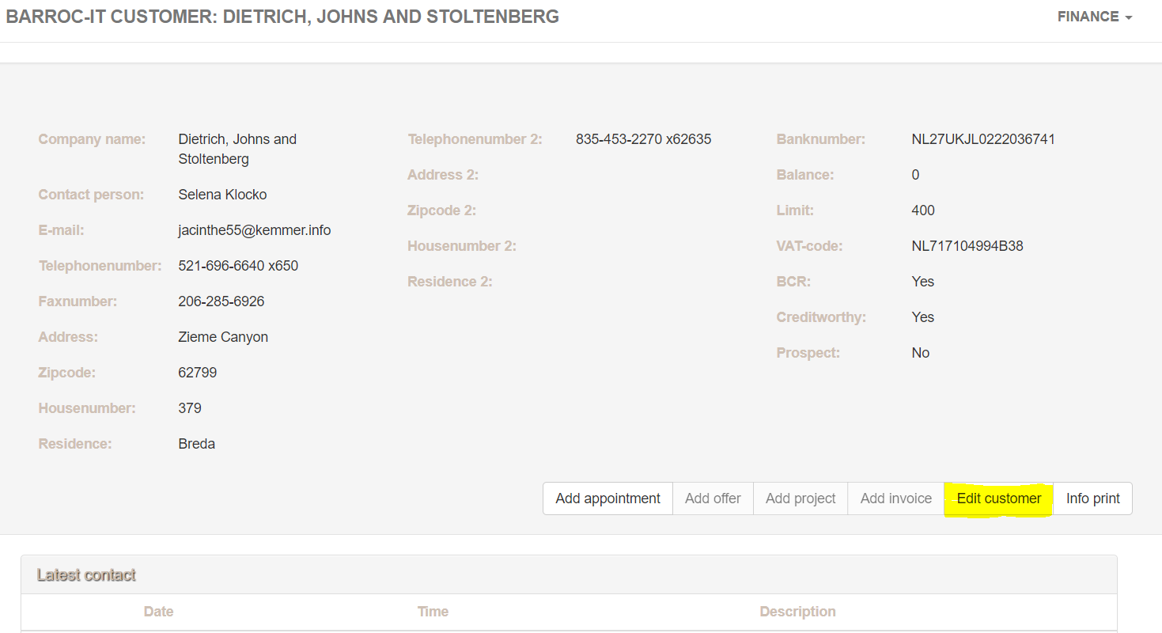

If we click on that we will be directed to an edit page where we can edit the info the finance department has the permissions and information for:

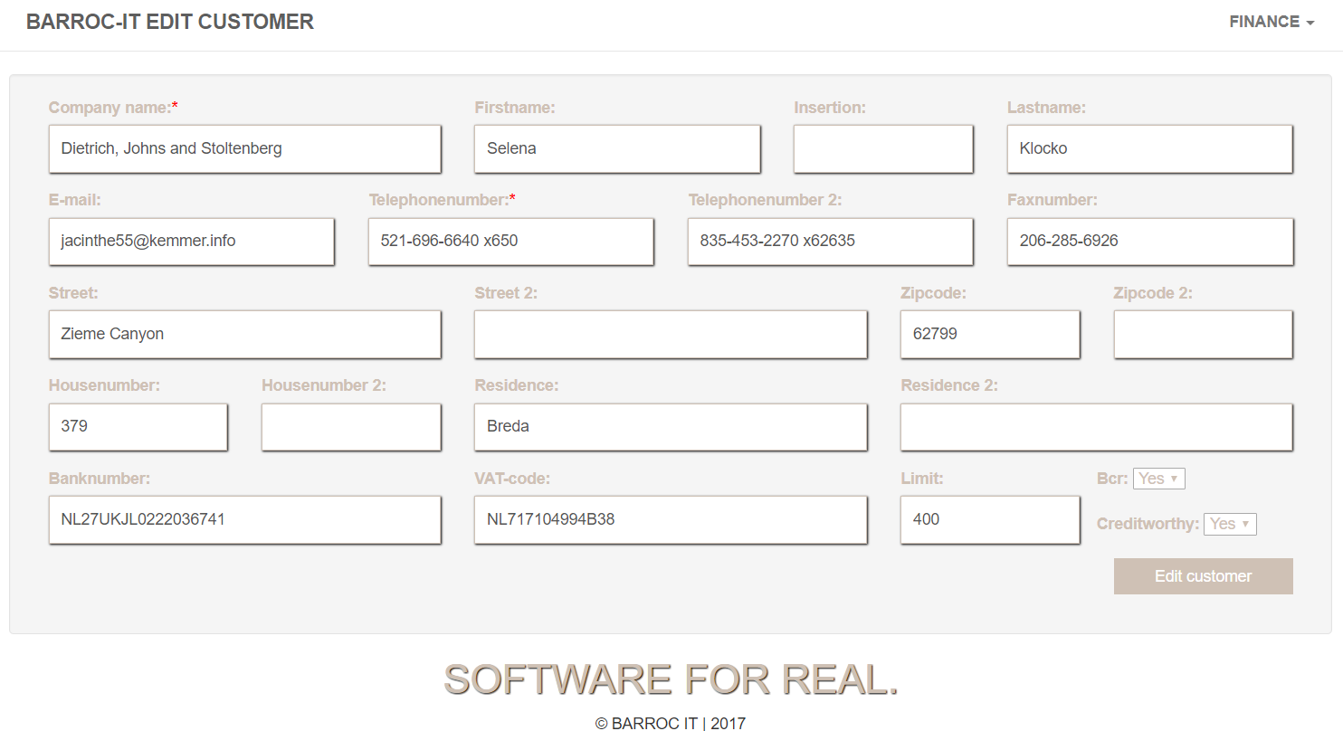

Once we’re done we can click on “edit customer” on the bottom right corner.

### Add invoice

If we want to add an invoice we need to be at the project info page (like we explained above).

Once we’re there we can click on “add invoice”.

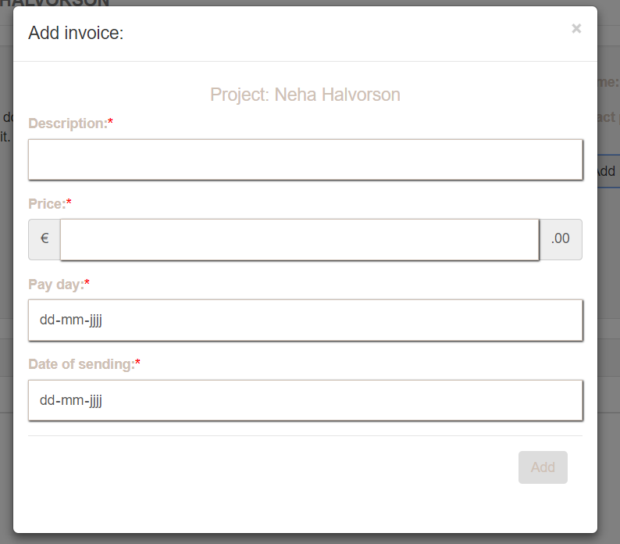

Once we have clicked on the “add invoice” a dialog will appear where we can fill in the info(note all the field need to be filled in). once were done we can click on “add” to add the invoice

### Change invoice status

If we want to change the status of an invoice we need to find the invoice we want to change the status of and click on the “green check mark” to set the invoice status to payed:

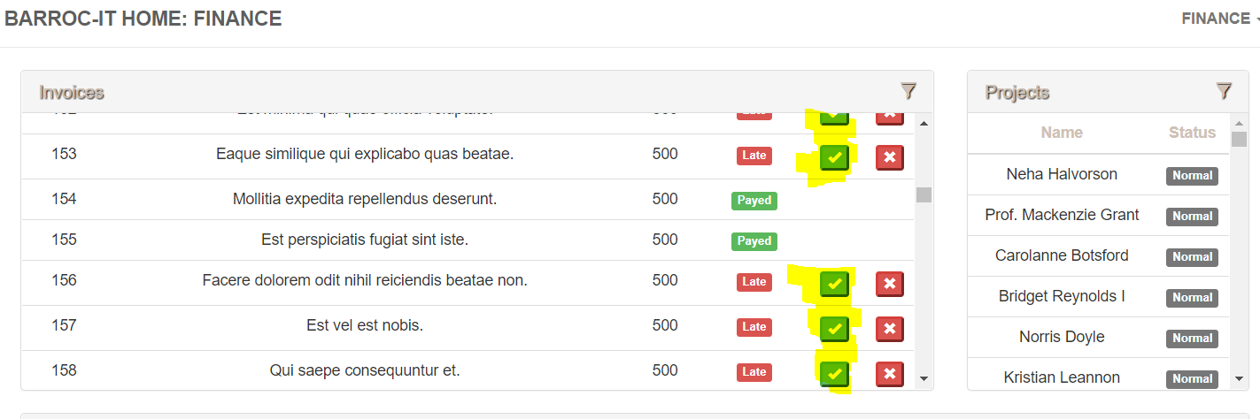

## Admin

We need to login as admin in order to work as a admin. Please read the login instructions above

### Home page

Once we’re logged in as admin we can view and see all the info of the above described departments.

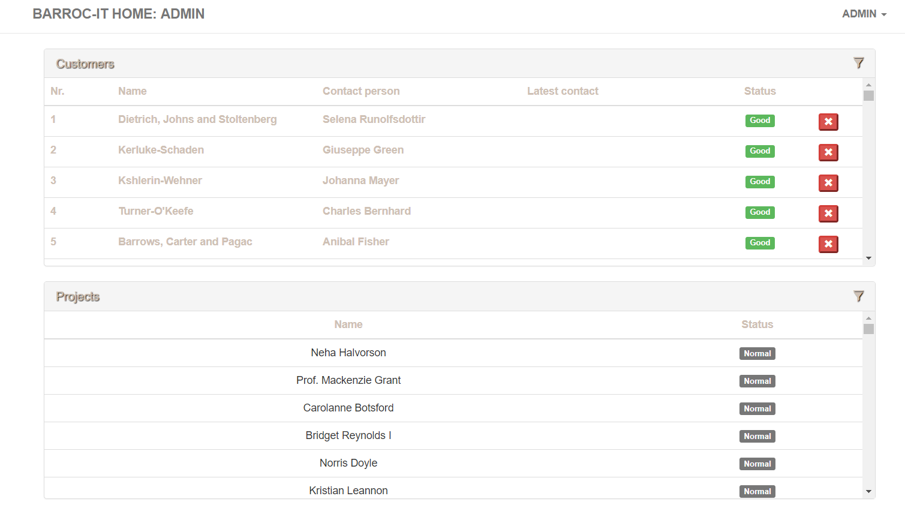

### Add user

If we want to add a new user into the system we can click on the “admin” on the top right of the screen:

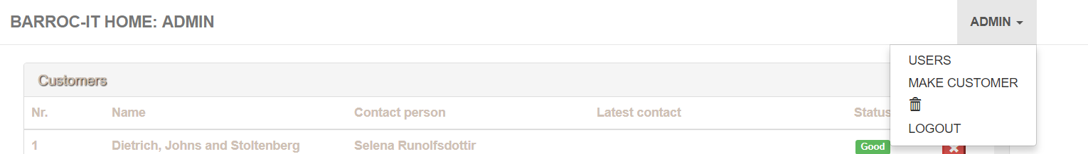

As seen above we get a hamburger menu with items.

Click on “users”

Once we clicked on user the following window will appear:

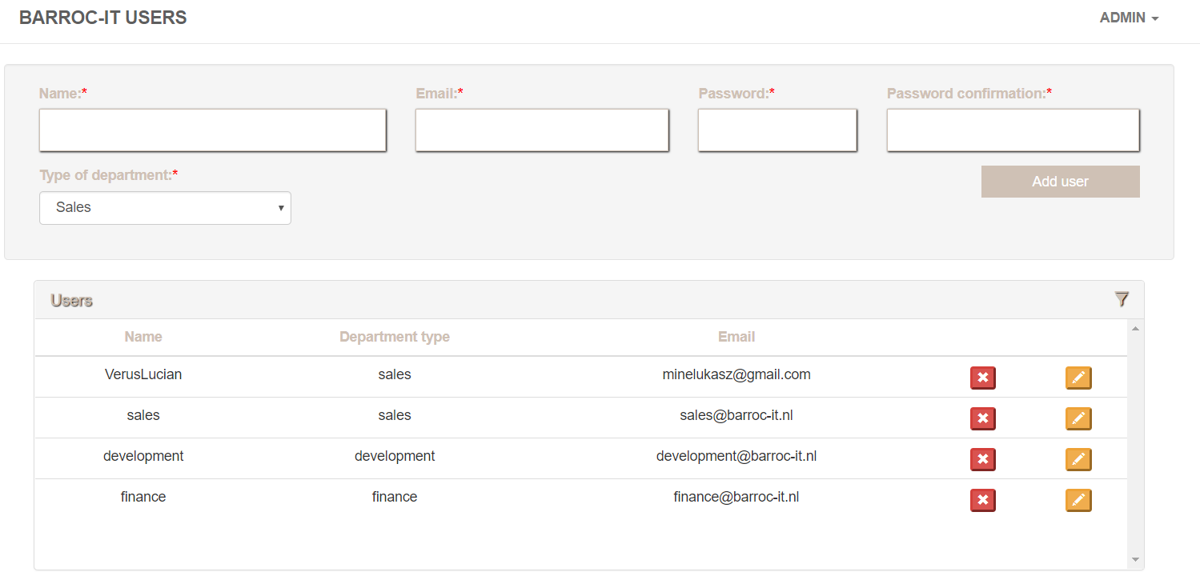

If we want to add a new user we need to fill in the required field for it:

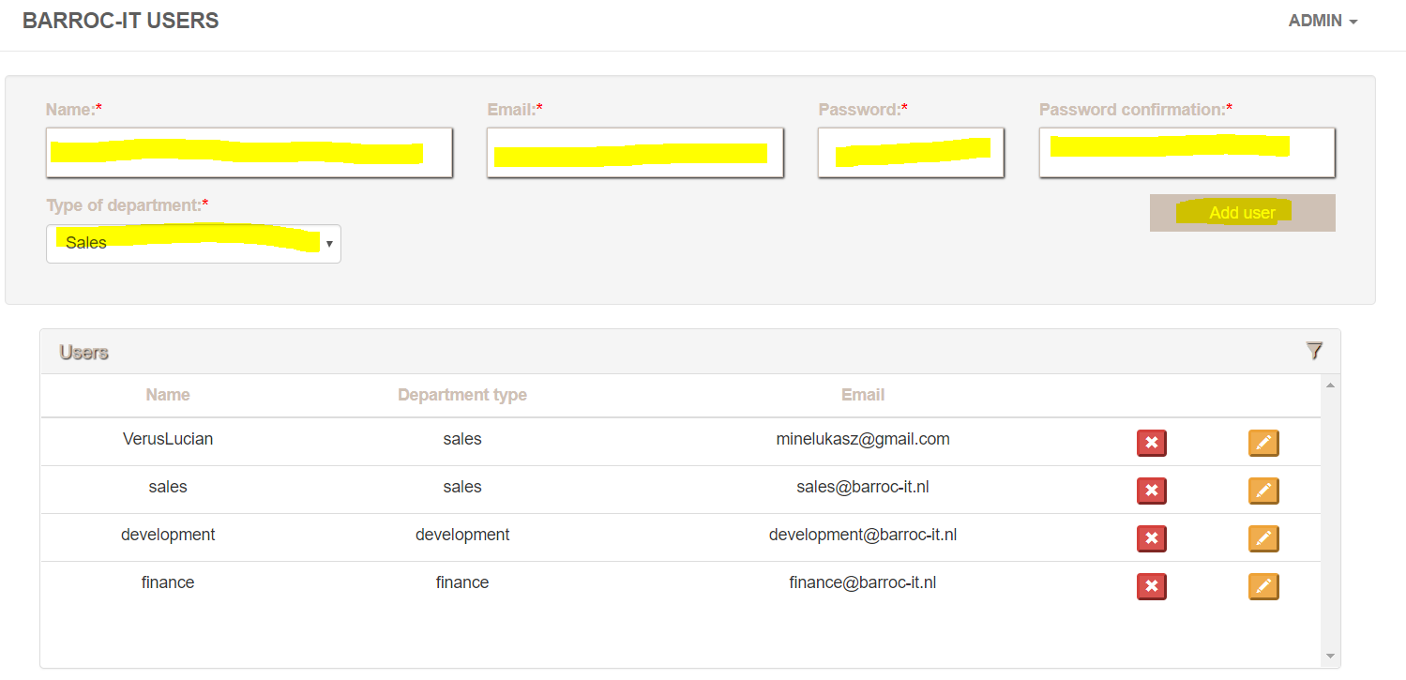

Once we have filled in the fields we can click on “add user” to add the user.

### Edit user

If we want to edit the user we click on the orange pencil next to the user:

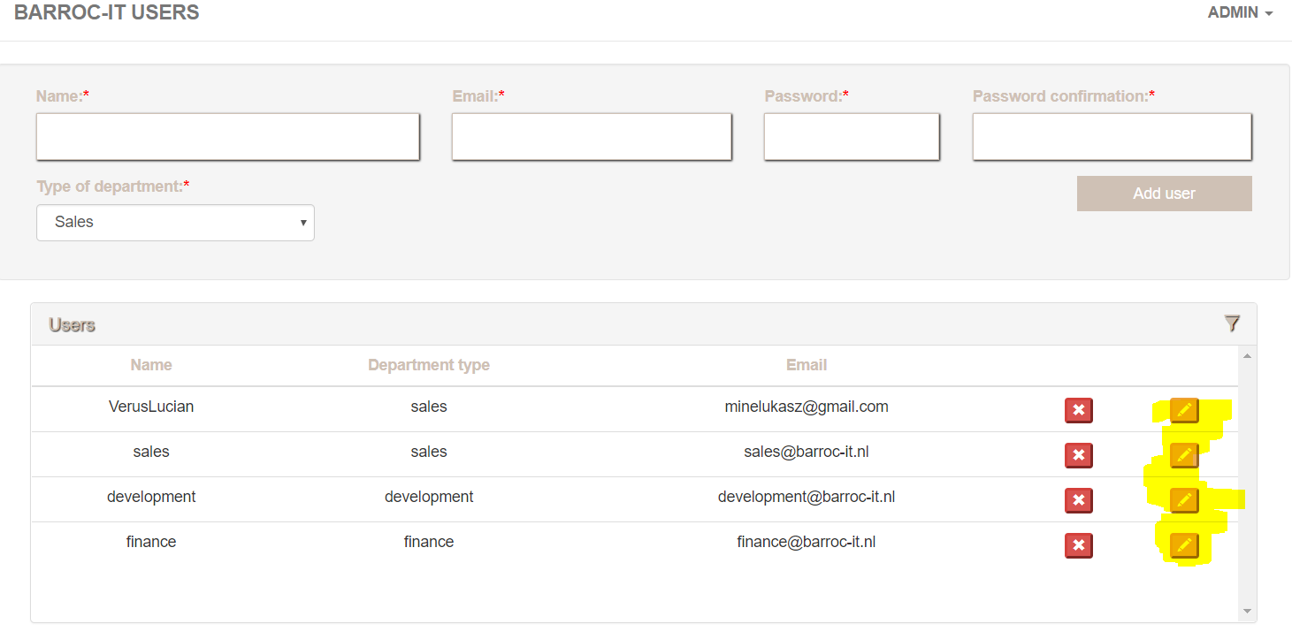

Once we clicked on it the following window will appear where we can change the user info:

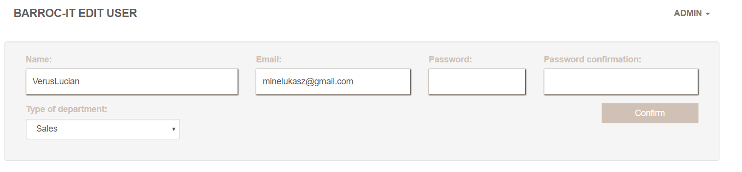

Once done we click on “confirm” and the user has been edited.

### Delete user

If we want to delete a user we go back to user (as explained above) and we click on the red cross next to the user we want to delete:

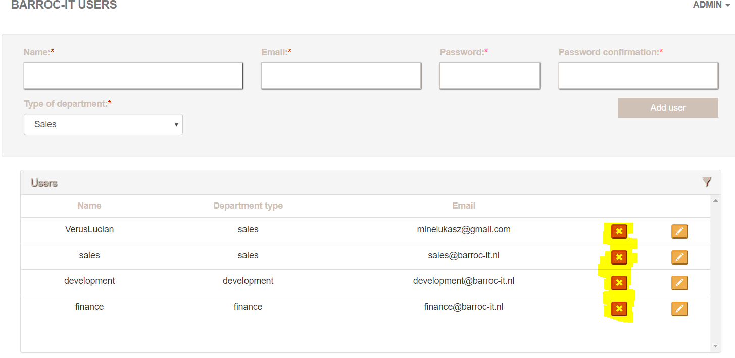

Once we clicked on it the user will be deleted.

### Trash bin

if we want to go to the trash bin we can click on our name on the top right corner and open the hamburger menu

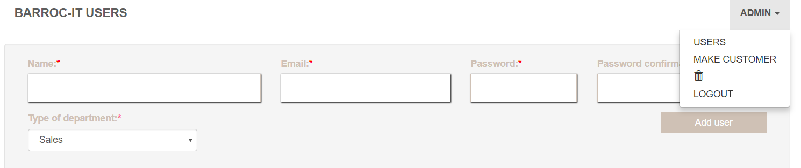

Once we clicked on it we see a trash bin. Click on the trash bin.

Once we clicked on the trash bin we get a view with everything that is deleted:

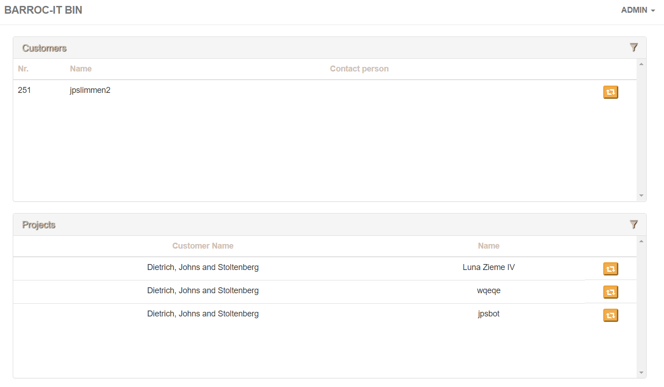

If we click on the orange recycle button we will restore all the date that has a link with each other.

And that’s all you can do in the trash bin and on how we can restore our data.